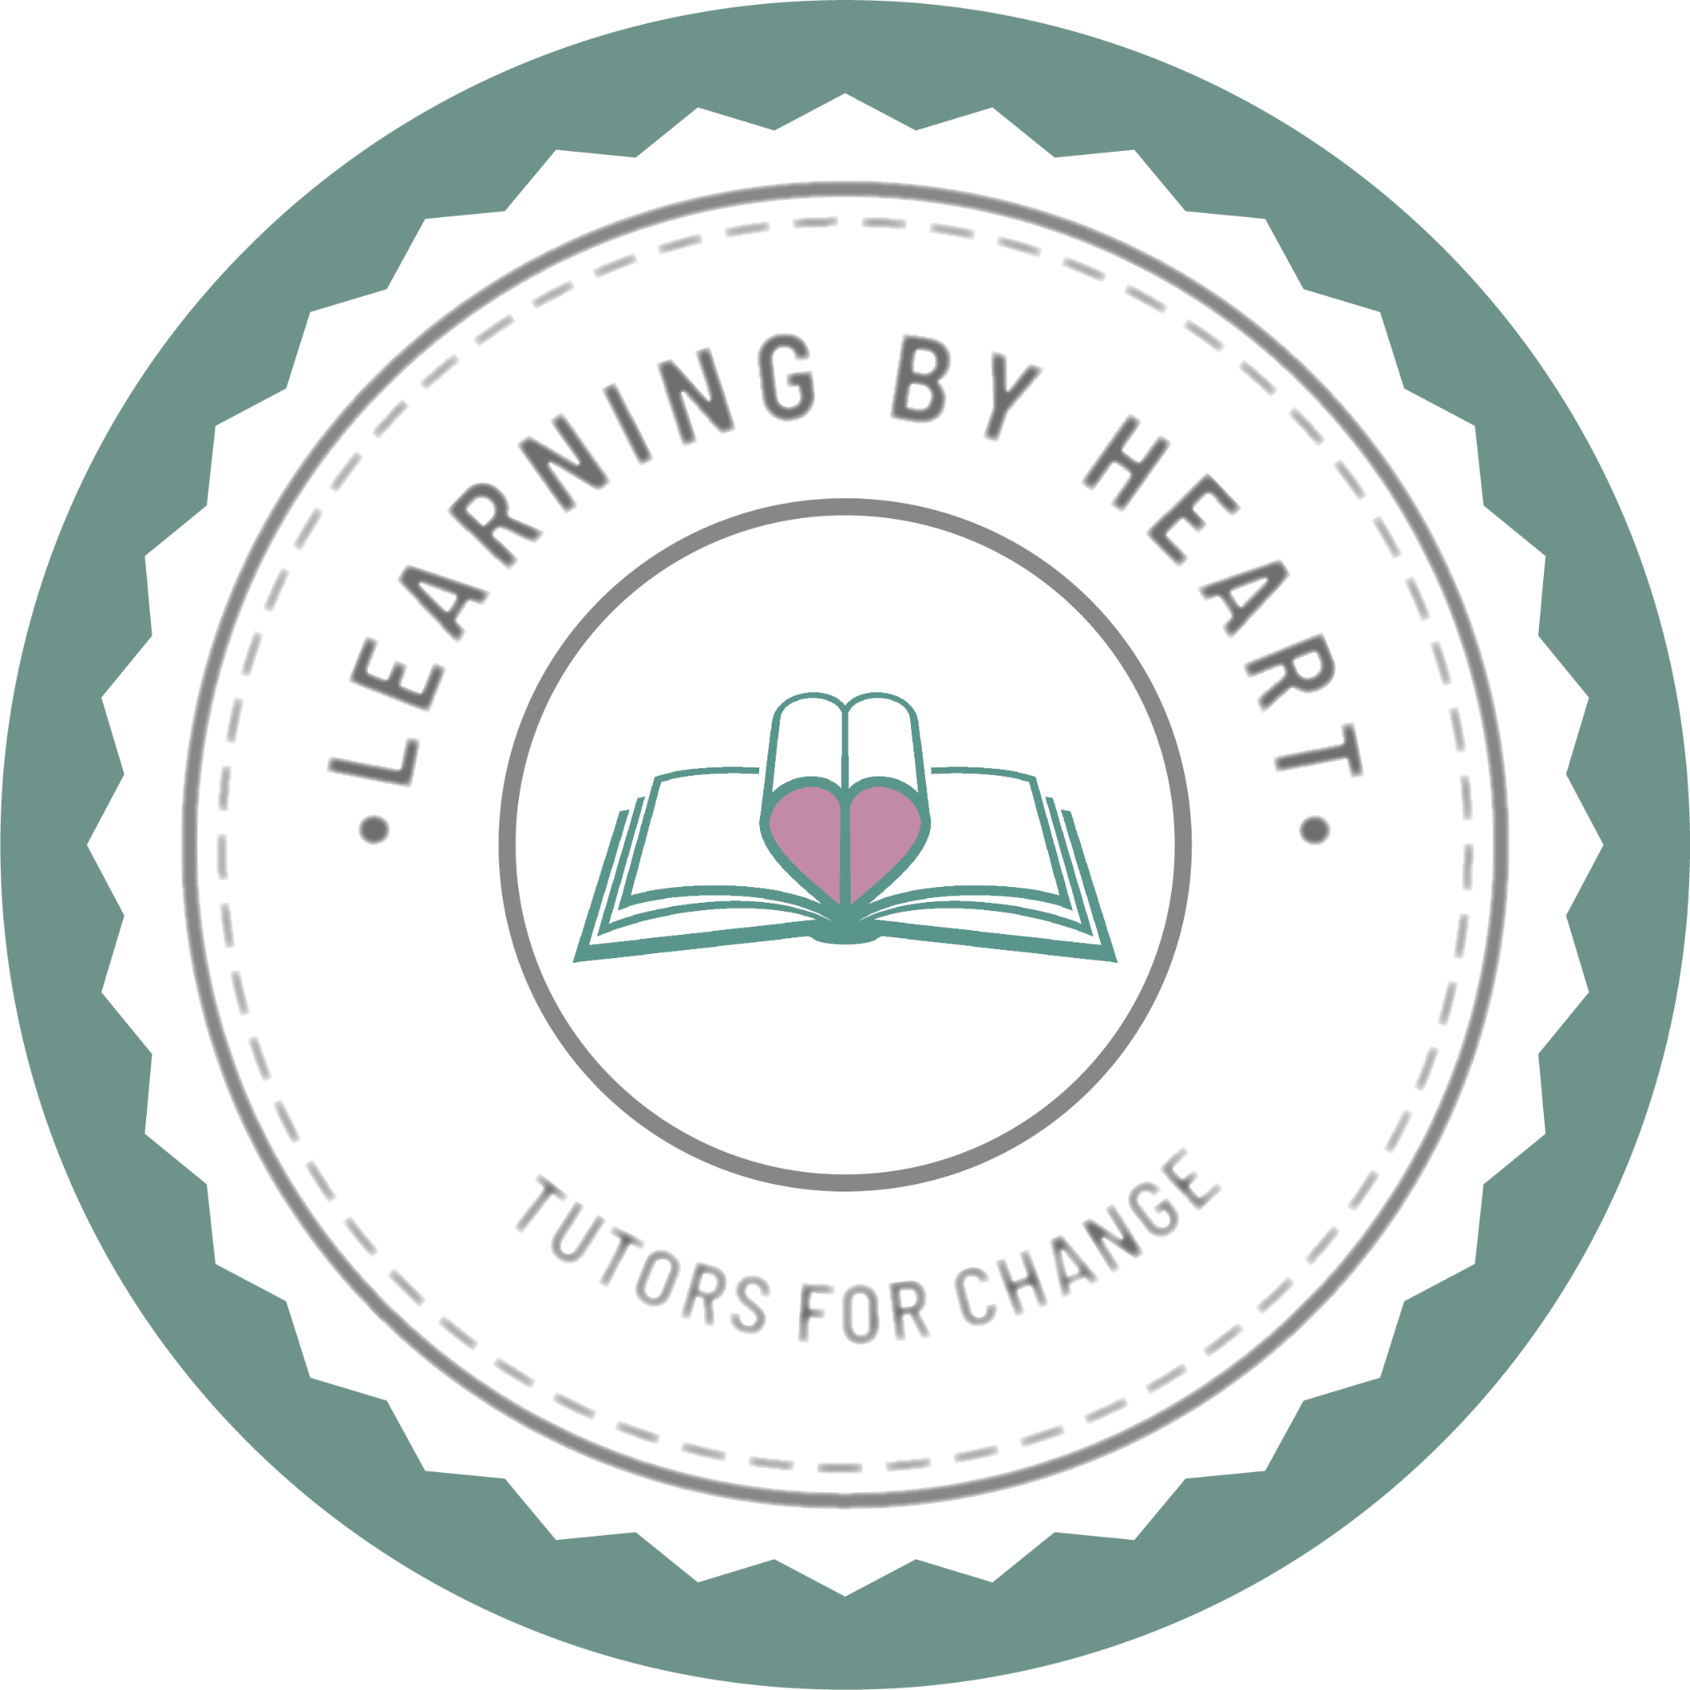

**HR Volunteer Role Profile**

Name: HR Volunteer

Hourly commitment: 3-4 hours per week approx.

Learning By Heart is an initiative with 2 principal goals: to provide children and adults in the UK with accessible educational support, while in turn helping to widen access to education for young people across the world. ​

We provide online classes in a wide range of subjects, run by volunteer tutors, in exchange for pay-as-you-feel donations to educational charities. Classes are delivered remotely using videoconferencing platforms, so we are able to reach pupils all over the country. Currently, our profits are donated to The Literacy Hubs, who work with local councils, communities and schools to create learning programs to meet their specific literacy needs. They do this by setting up individually designed hubs to best support the community it serves.

Learning By Heart is currently run by a management team of 11 volunteers. However, as the organisation grows and the responsibilities increase, we are looking to expand the team. We are looking for a new enthusiastic and reliable HR Volunteer to support the expansion and development of the Learning By Heart team, building and maintaining a skilled and supportive network of volunteers.

Role responsibilities:

* Assist with recruitment of Learning By Heart volunteers (in areas: Tutoring, Human Resources, Fundraising, Social Media and Outreach/Partnerships)
* Alongside the project director, interview candidates remotely using video conferencing software.
* Provide administrative support where necessary.
* Help handle new class sign ups and match pupils to tutors.
* Help monitor class donations.
* Communicate with pupils/parents and tutors on a regular basis to check classes are running okay and ensure they have the support needed.
* Assist with coordinating DBS checks and safeguarding for new volunteer tutors.

The role and its responsibilities will evolve as the organisation grows. This is a very flexible role and most activities can be completed whenever you have the time making it a perfect volunteer role alongside other commitments.

To express your interest, please complete the following form:

<https://docs.google.com/forms/d/e/1FAIpQLScQT-cQ6tH7MMFPnQLw9iFtA0w1geIfbjgSojttTkww3FkQtg/viewform>

For more information about our organisation, please visit our website: <https://www.learningbyheart.info/>